|  |
| --- |
|  |

|  |
| --- |
| **DECLARATION SYSTEM** |
|  |
|  |
|  |
|  |
|  |
|  |
|  |

Table of Contents

1 Introduction 2

2 Problem Statement 2

3 Recommendation 2

4 Functional And Non-Functional Requirements 3

5 USER STORY 4

6 Extended Entity Relationship Diagram 6

7 Flow Chart 7

8 SWOT ANALYSIS 8

9 SWOT/PEST ANALYSIS 9

10 DFD 9

11 USE CASE 11

# Introduction

Overview

Easy Declaration is a website based system designed to assists student to declare their devices electronically. This documentation defines the scope of Easy Declaration and the general description of functionality.

The Easy Declaration system consists of two actors, the admin and student. The admin is responsible for monitoring the whole systems and validating details of new users. Student are required to register in the system before they can be able to declare their items. Items that students can declare include an oven or microwave, laptop, desktop computer, speakers, a bar fridge and a television. After declaring students can print out their declaration form which has the required details to prove that the item belongs to them. Many items can be declared but an item cannot be declared twice.

Objectives

The specific objectives of the project include:

* Reviewing the current method use when declaring students items
* Coming up with a new method that will reduce paperwork and time when declaring items
* Providing a detailed documentation of the online system
* Implementing the Easy Declaration website

# Problem Statement

* The current method used for declaration of items requires students to physically go declare their items at the control office.
* The current system uses an excel spreadsheet to store declared items.
* Students required to go declare their items again if they misplace there declaration form
* Other campuses in fact do not have a declaration system let alone the excel spreadsheet that is being used in Soshanguve south campus.
* The current system is time consuming for both students and securities.

# Recommendation

We recommend the implementation of a website based declaration method. The system “Easy Declaration” maintains two actors, the Administrator and User respectively. The student can access the system at any time and also declare items at any time upon registering. Students will be able to print out their declaration form via the website.

The recommended system provides the following advantages:

* Saves time – items can be declared online, anytime and anywhere, 24/7
* Declaration Form – student can print the form whenever they lose their form
* Items – students can declare as many items as they want, but each item can be declared once
* Usability – the system is user friendly and students can interact with it
* Information – all information is saved in a database so that it can also be easy to retrieve it again when needed

# Functional And Non-Functional Requirements

Functional

* The system should allow users to register and login
* It has to validate and verify admin login credentials
* The system should allow the student to declare items
* The system should restrict the user from declaring the same item twice
* The system should allow a user to request for change of ownership
* The system should allow the admin to make change of ownership if requested by a user
* The system should allow the student to delete and update the items
* The system should all the admin and the student to print proof of declaration
* The system should validate and verify student login credentials
* The system should alert a student in case his/her device was stolen and the person who stole the device tried to declare it again

**Non-functional Requirements**

* Availability: The system must be available all the time and at all campuses
* Usability: The system should be user friendly and easy to interact with.
* Capacity: The system should be able to process large amount of data
* Back-up: System data should be backed up periodically in order to avoid loss of data.
* The system should be backed up over cloud storage.
* Scalability: The system should have the ability to scale by adopting new generations of components
* Security: The system should have access controls, which prevent unauthorized personnel from accessing sensitive data.
* The system should be able to detect security breaches

.

# USER STORY

|  |  |  |  |
| --- | --- | --- | --- |
| **USER STORY ID** | **AS A TYPE OF USER** | **I WANT TO** | **SO THAT I CAN** |
| Stud_001 | Student | Register to the system | Have an account |
| Stud_001 | Student | Login to the system | Be able to use the system |
| Stud_001 | Student | view | Be able to see which devices has to be declared |
| Stud_001 | Student | Enter device | Be able to declare devices |
| Stud_001 | Student | Save the declaration form | Be able to store the declaration in the database |
| Stud_001 | Student | view | Be able to view the information of the declared devices |
| Stud_001 | Student | check | See if the device has been declared again. |
| Stud_001 | Student | Update | Be able to update the device on the system |
| Stud_001 | Student | Delete | Be able to delete device from the system |
| Admin_001 | Admin | Print reports | Be able to print reports from the database. |
| Admin_001 | Admin | view | Be able to see which devices has been declared |
| Admin_001 | Admin | monitor the system | Be able to see if it works properly |
| Admin_001 | Admin | Update profile |  |
| Admin_001 | Admin | Create declaration form | Be able to record all the devices which has been declared |
| Admin_001 | Admin | Delete | Be able to delete the student’s account and also delete the stolen devices from the system |
| Admin_001 | Admin | Send notification | Be able to confirm that device has been declared |

# Extended Entity Relationship Diagram

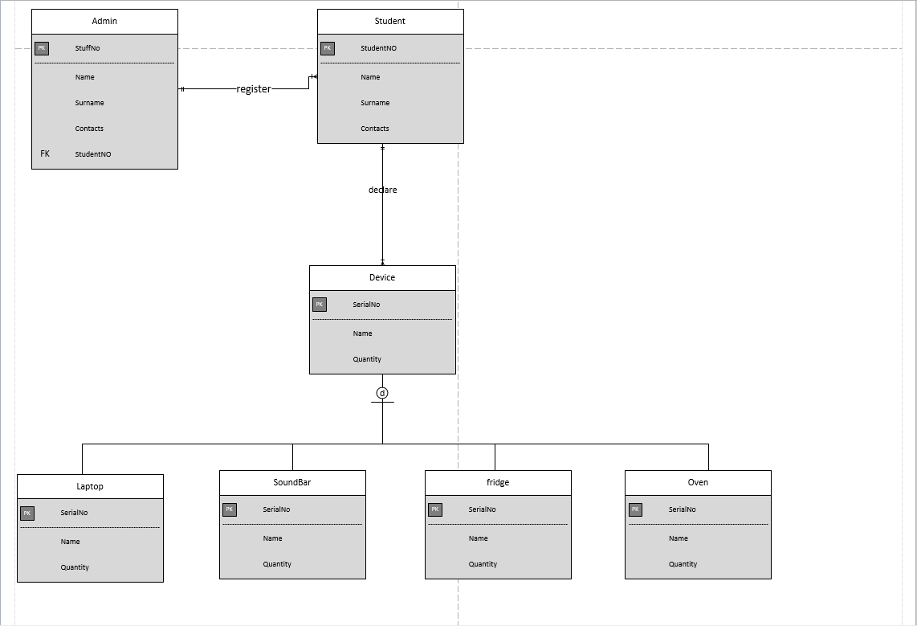

# Flow Chart



# SWOT ANALYSIS

|  |  |
| --- | --- |
| **Strengths**   * The declaration system increases security for each student’s device. * The implementation of this system will not allow unauthorised users to access devices which are not theirs. * The system is user friendly and easy to use | **Weaknesses**   * The system needs internet access. * Other varsity students may not trust the system with their own expensive devices. * Many students can use the system and it may suffer from buffering |
| **Opportunity**   * It decrease the time and money of travelling where you are to admin for seeking help of declaring your devices. * The system increases accessibility to students * The system will come up with better opportunities and be more efficient | **Threats**   * Some students can still try to crack the system to get unauthorised access of other’s devices. * Some students can steal other’s devices and declare it before the owner can declare it. |

# SWOT/PEST ANALYSIS

|  |  |  |  |  |
| --- | --- | --- | --- | --- |
| **SWOT/PEST** | **STRENGTHS**  **(S)** | **WEAKNESSES**  **(W)** | **OPPORTUNITIES**  **(O)** | **THREATHS**  **(T)** |
| **POLITICAL ASPECT (P)** | The system will  Enable Student to declare their devices. | Students can be hesitant in trying the Easy-Declaration system. | It gives students a chances to be more reliable about their devices | Competitions among the different businesses. |
| **ECONOMIC ASPECT (E)** | By creating the declaration system will save time for students by going to the admin for long queues | Implementation costs. | It opens doors for people who are computer literate to become the system administrators. | Economic threat for increasing of technology costs |
| **SOCIAL ASPECT (S)** | Creating the system will attracts other varsities and get potential investors. | Students who don’t have internet access won’t be able to use the system. | It will reduce the paperwork process for workers. | Students might not use the system as trust in technology is still an ongoing disadvantage of technology. |
| **TECHNOLOGICAL ASPECT (T)** | The system will reflect the technology on the students and varsity staff. | Since the system will be used by many people it may suffer from buffering. | It will present opportunities for better, cheaper and more efficient e-services. | If the phone is off the system can’t be accessed. |

# DFD



# USE CASE

